In the following report, you can find the recommendations that as IT experts, we consider are the best options to improve considerably your business growth.
These recommendations are focused in prove your website speed, to migrate securely from on premises to cloud services, allow you to use containers such Dockers to store files and data, allow you to increase your sales by distributing your company brochure on the right time and use a database with redundancy to ensure high availability. All this by following the budget matters and using all the AWS services available to reach your goals.
AWS offers a huge amount of range of services, that can be use them in group to manage your business. All of them are directed to all types and sizes of business and if you need to grow up, Amazon scale up with you, modifying every service according to your needs.

Task 1: Move the company website to a Linux Server
Host your Website in a Linux server its one of the things that is going to speed up your changes on your website, since now you can have full access to your html files, you can modify them and apply the changes immediately as many times as you need, without leaving your workspace.
A cloud service also will also help you to safe all your information, there won’t be problems to access to it in case the server fails or something, since everything in the cloud is safe have high availability and redundancy.
In resume
1) I created a EC2 Ubuntu instance
2) I connected to it through its public IP address
3) I downloaded Apache and granted permission of access
4) Used File-zilla to upload the website.
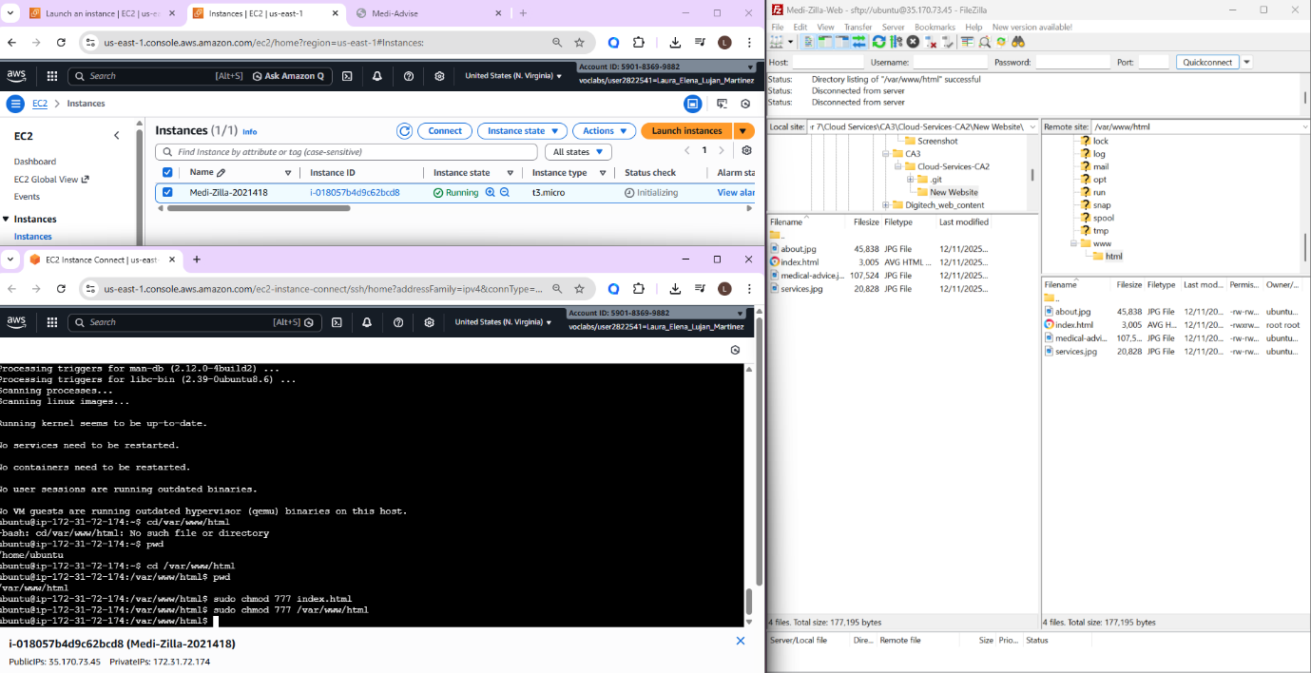
Figure 1. Step 1-3. Process of Uploading a website to Ubuntu using File-Zilla
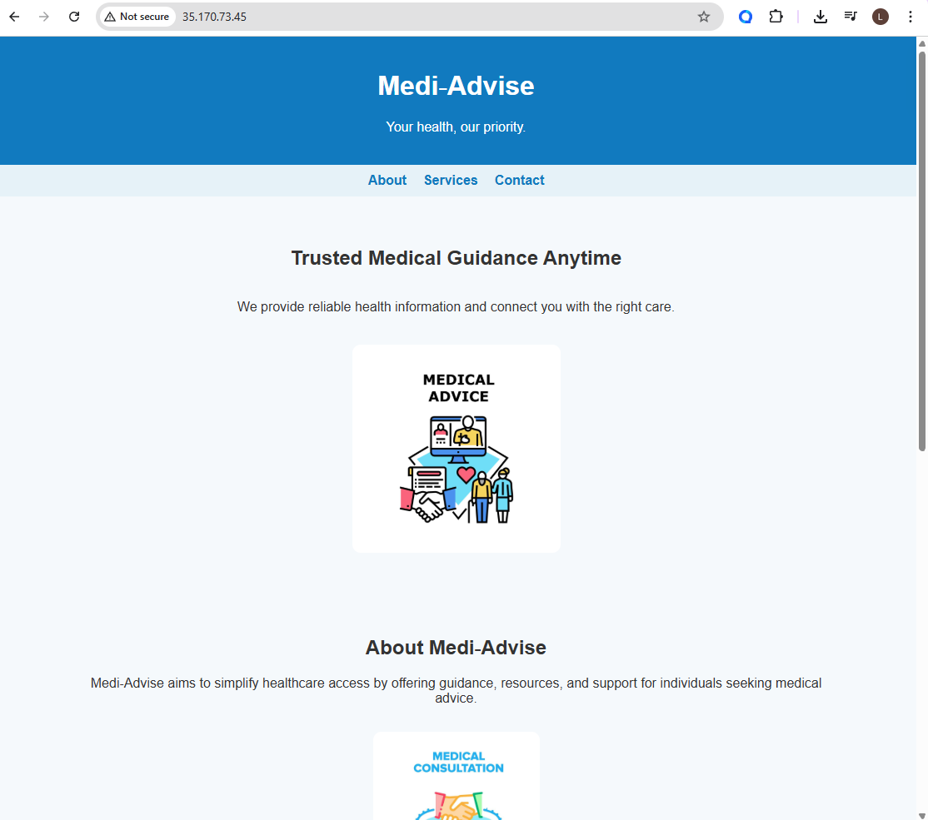
Figure 2. Step 4. Medi-Advise website hosted successfully
Task 2: Put the website in a Docket container
Task 3: Explain how CDN would speed up brochure downloads
To solve the problem of the download time of your brochures, we need to use Content Delivery Network, this is a service that AWS also offers under the name of CloudFront and will solve the problem in the slow download time.
An easy way to explain it is this: If your content of origin in Ireland, then how long time will your brochure be visible if someone decides to access to it in LA? There is where the slow download time appears, since the origin location and the client could be a continent far away.
CloudFront offers “Edge Locations”, this means that if someone access to your brochure near one of the edge locations points distributed around the world, this edge location will keep a copy in cache of your brochure, meaning that the next time someone near USA wants to access to it, the information do not need to travel from Ireland all the way to USA, CloudFront will actually show to the client the brochure stored in cache. In this way not only the information doesn’t have to travel that long, also, your origin instances will reduce the traffic.
For this case we are talking about a brochure, but it could be used for many cases such an S3bucket, instances etc.
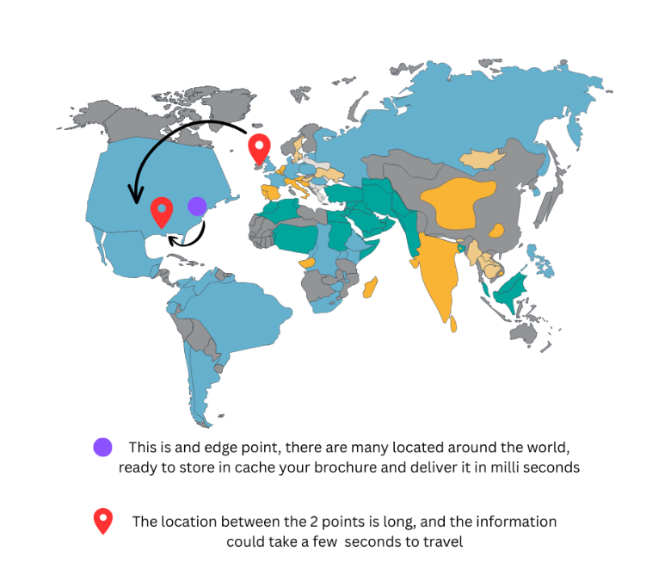
Task 4: Demonstrate Samba Server
Task 5: Show 2 departments can still communicate is mitigate to AWS
Task 6: Demonstrate Cloud Formations
Cloud formations is the part of AWS where you build your own infrastructure as a Code, this means you only need a bit of code to start creating for instances that contains already what you need, in a fast and scalable way. This service is the start of your environment to set the basics characteristics of your infrastructure and make it easy and safe. CloudFormation also has templates and version control, this means that if case of mistake, it will be easy to go back without any problem, it is possible also to update the templates or just delete them with no major consequences.
As a result, built many different environments, that are reusable, maintainable and can be repeated as needed. Medi Zilla con perfectly start expanding and automating services in this way, since on premises data centres are suitable more for small business, Medi Zilla already have the need to automate services ensuring a smooth transitions with services like Cloud Formation.
Let’s see how it works in just simple steps.
- Create a CloudFormation stack to deploy a Linux EC2 instance on the Default VPC.
This is an example of how Medi Zilla could launch instances by templating them in a “stack”, these templates contain information such as OS of your instances, buckets, storage etc.

  - I first modified the yml file, where I specified what type of instance I’ll create, this template will create my instances automatically, for this case my instance is an Ubuntu 24.04
  - I created a stack template, where I’ll upload, he yml file.
  - Verify the template is created.
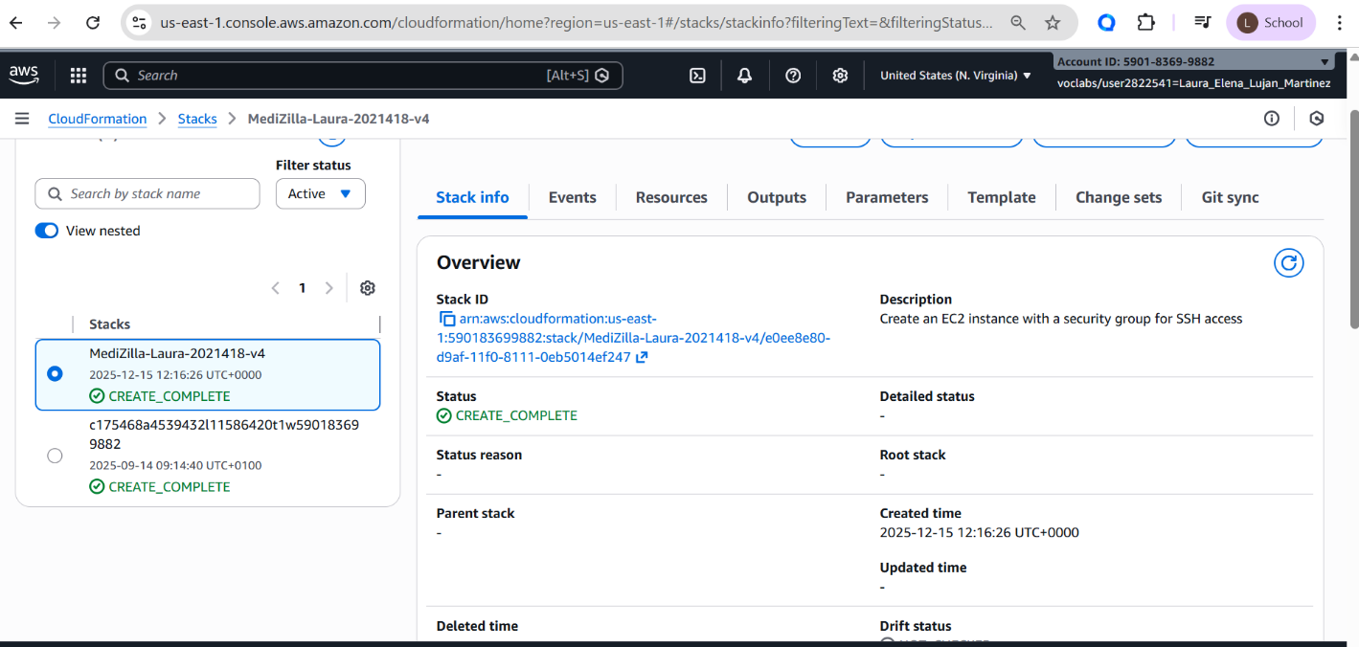
Figure 3. See steps 1.1,1.2 and 1.3. Create a stack template with yml to create an instance

- Implement a ‘Change Set’ on CloudFormation and add port 80 to the EC2 instance.
Lest say that Medi Zilla need to have port 80 open to host a website for the public. Now it’s possible to make changes to that template we just created by using “Change set” options.
2.1) Here I copied I pasted the templates I had to create a new one, which is my 4th yml file. To that file I just added the port 80 right under the port 22 it already existed.
2.2) Update the Change set as previously. And verify the changes on the instances
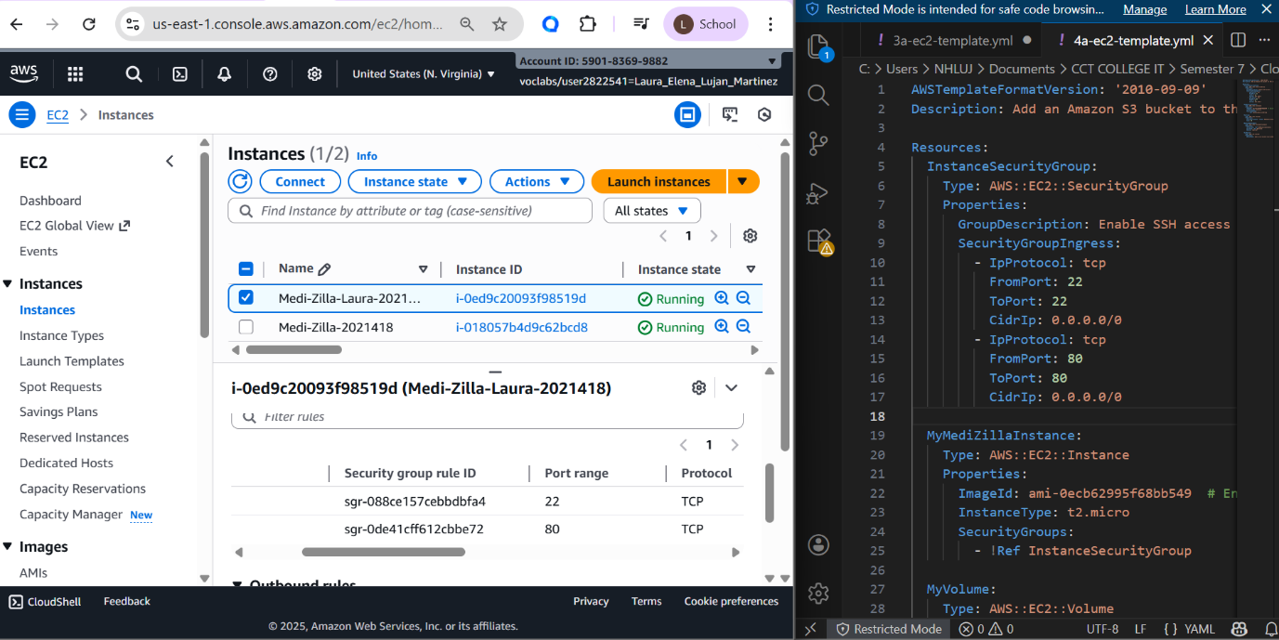

- Continue with CloudFormation another ‘Change-Set’ and demonstrate that you can enhance the storage layer of the Linux EC2 instance by adding an additional 10GB of Elastic Block Storage (EBS).
Same case, update the template as many times as needed, Medi Zilla is going to grow and change, and AWS will allow it without putting in risk all the stacks or environments that were already created.
3.1) I Updated the yml file with the instance name, and define how many GB are need, for this case, 10GB in EBS
3.2) Create a change set
3.3) Update the file. The changes are immediately
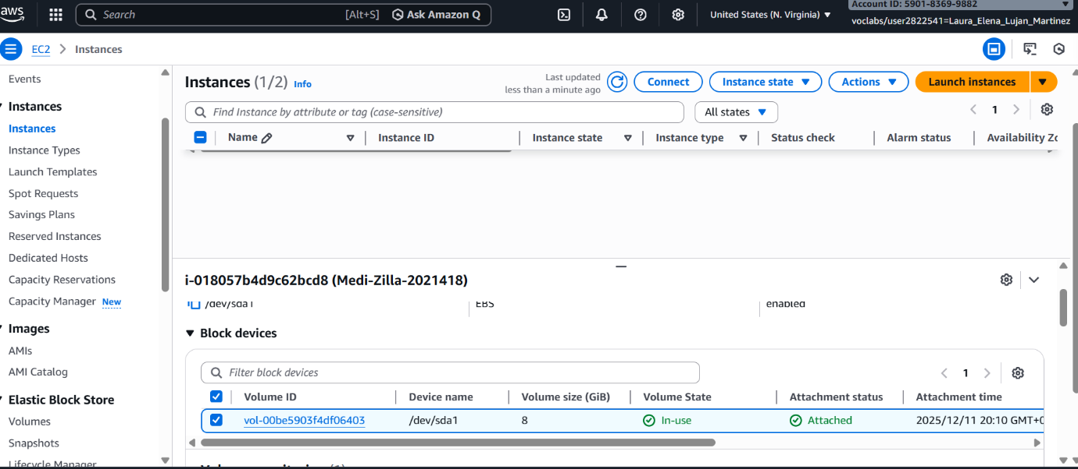
Figure 4. EC2 instance with 8GB in volume size
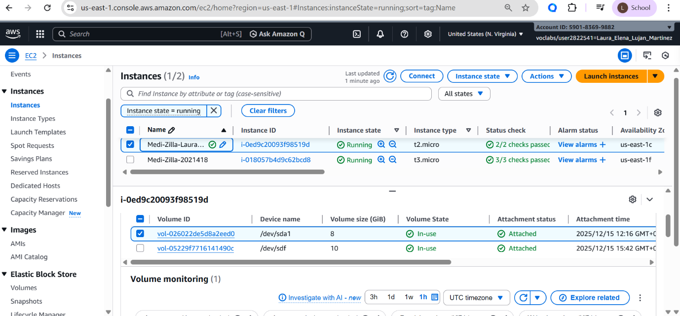
Figure 5. EC2 instance with 10GB of volume size

- Demonstrate that you can enhance the storage layer even more by having another CloudFormation ‘Change-Set’ add a Simple Storage Solutions (S3) bucket that has a name that includes your name and your student number.
This bucket is where all the static files will live, for example the website, or the brochure
4.1) I modified the template with my unique personalized bucket name
4.2) Create a new change set
4.3) Upload the new file
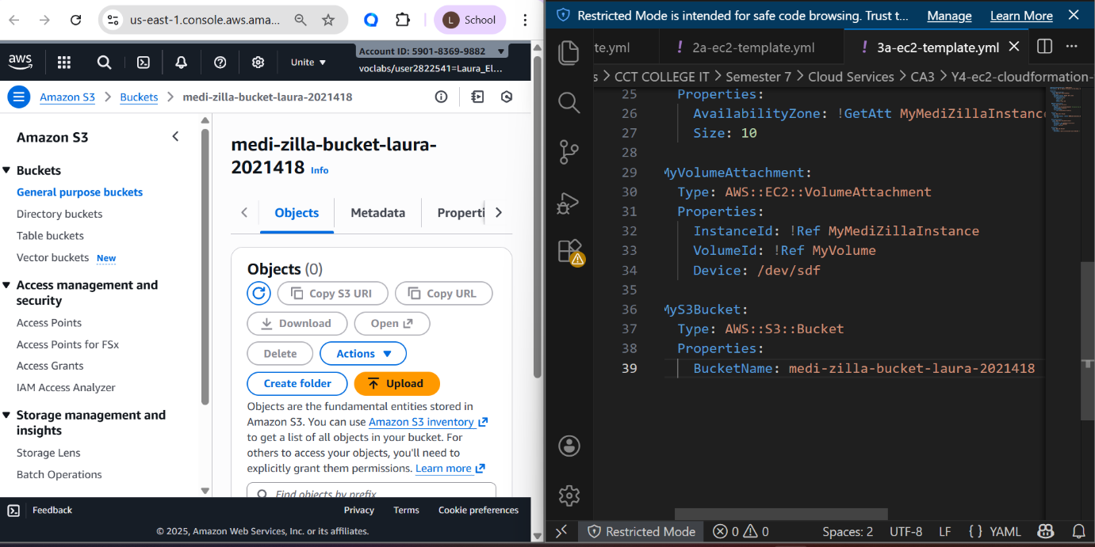
Task 7: Create a Database in AWS with redundancy
Task 8: Research modern data centre growth and trends

